**Lesson 5 Demo 1**

**Validation of Apache Web Server**

**Objective:** To validate the Apache Web Server set up using Ansible

**Pre-requisites:** You need to have Ansible installed to proceed with this demo. If you don’t have it installed, refer to demo 1 of lesson 2.

**Tools required:** Ubuntu terminal and Ansible

**Steps to be performed:**

1. Establishing connectivity between Ansible controller and node machine
2. Writing Ansible YAML script to install Apache server
3. Running Ansible YAML script
4. Validating Apache Web Server setup

**Step 1: Establishing connectivity between ansible controller and node machine**

1. Establish SSH key pair in Linux system to have SSH connectivity with localhost using the following command:

***ssh-keygen -t rsa (****Press Enter when asked for an input****)***

***cat .ssh/id_rsa.pub >> .ssh/authorized_keys***



***ssh localhost -p 22***

1. Now, add the host localhost in ansible host file ***/etc/ansible/hosts***

***sudo vi /etc/ansible/hosts***

1. When the file opens, add the below two lines of the code at the end of the file if not added already:

***[webservers]***

***localhost:22***

1. Execute the below command to validate host inventory file

***ansible -m ping webservers***

**Step 2: Writing Ansible YAML script to install Apache software**

1. Once connectivity is established, add the following code to the apache.yaml file and proceed with execution
2. Create and open the file using the below command

***sudo vi apache2.yaml***

***---***

***- hosts: webservers***

***become: true***

***tasks:***

***- name: install apache2***

***apt: name=apache2 update_cache=yes state=latest***

***- name: enabled mod_rewrite***

***apache2_module: name=rewrite state=present***

***notify:***

***- restart apache2***

***handlers:***

***- name: restart apache2***

***service: name=apache2 state=restarted***

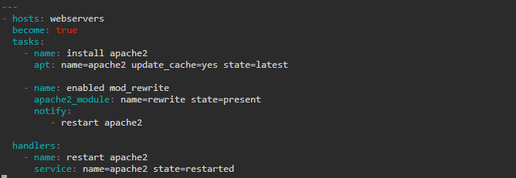

**Step 3: Running Ansible YAML script**

1. Run the ***apache.yaml*** file using the below command:

***ansible-playbook apache2.yaml***

**Step 4: Validating Apache Web Server setup**

1. Validate the installation using the command:

***ansible -m shell -a "service apache2 status" webservers***

